**ECE 3723**

**Project 5**

**Tri Pham**

**Nguyen vu**

**Dung Nguyen**

**Introduction**

In this project, we will discover something that we never work on. Using the given function to make the plot for Fourier transformation function to represent the periodic function. Also see what are the different when we repeat many times.

*Plot the function v(t) vs t from -T to 3T. (10 points)*

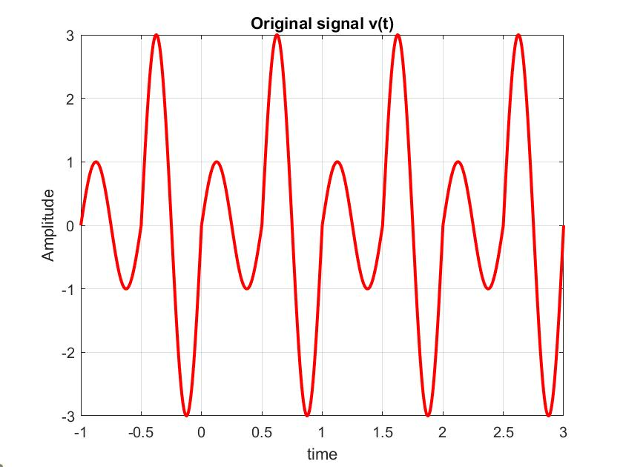

*What symmetries (if any) apply?*

This function does not have any symmetry because f (0.7) = 1.7 and f (-0.7) =

-0.58. Also, from 0 to T, there are two different functions so that it will give us the different answers.

*Derive the Fourier series representation of the function. Show all steps of the derivation. Type all steps,  
absolutely no credit will be given for handwritten answers*

Av = $\frac{1}{T}\int_{0}^{T}{f\left(t\right)dt}$

= $\frac{1}{T}\int_{0}^{T/2}{Vm*\sin\left(\frac{4πt}{T}\right)dt}$ + $\frac{1}{T}\int_{T/2}^{T}{3Vm*sin\left(\frac{4πt}{T}\right)dt}$

T = 1, Vm = 1.

= $\left[-\frac{\cos\left(4πt\right)}{4π} \right] {1/2 \atop 0}$ + 3 $\left[\frac{-cos⁡(4πt)}{4π}\right]{1 \atop 1/2}$

= $\left[-\frac{\cos\left(4π*\frac{1}{2}\right)}{4π}+\frac{cos⁡(0)}{4π}\right]$ + 3 $\left[-\frac{\cos\left(4π\right)}{4π}+\frac{cos⁡(2π)}{4π}\right]$

= $\frac{-1}{4π}$ + $\frac{1}{4π}$ +3 $\left(\frac{-1}{4π}+\frac{1}{4π}\right)$

Av = 0

Bk = $\frac{2}{T}f\left(t\right)\sin\left(kw_{0}t\right)dt$ $\frac{2}{T}\int_{0}^{T/2}{Vmsin\left(4πt\right)\sin\left(kw_{0}t\right)dt+}\frac{2}{T}\int_{T/2}^{T}{3Vmsin\left(4πt\right)\sin\left(kw_{0}t\right)dt}$

Vm = 1, T = 1.

Int 1

$\int_{0}^{1/2}{\left[\cos\left(4π-k2π\right)t-\cos\left(4π+k2π\right)t\right]dt}$

$$\left[\frac{\sin\left(4π-k2π\right)t}{4π-k2π}\right]{1/2 \atop 0}-\left[\frac{\sin\left(4π+k2π\right)t}{4π+k2π}\right]{1/2 \atop 0}$$

$$\left[\frac{sin⁡(2π-kπ)}{4π-k2π} -\frac{sin⁡(2π+kπ)}{4π+k2π}\right]$$

Int 2

3 $\int_{1/2}^{1}{\left[\cos\left(4π-k2π\right)t-\cos\left(4π+k2π\right)t\right]dt}$

$$3\left[\frac{\sin\left(4π-k2π\right)t}{4π-k2π}\right]{1 \atop 1/2}-\left[\frac{\sin\left(4π+k2π\right)t}{4π+k2π}\right]{1 \atop 1/2}$$

3 $\left[\frac{sin⁡(4π-k2π)}{4π-k2π}-\frac{\sin\left(2π-kπ\right)}{4π-k2π}-\left(\frac{sin⁡(4π+k2π)}{4π+k2π}-\frac{sin⁡(2π+kπ)}{4π+k2π}\right)\right]$

3 $\left[\frac{\sin\left(4π-k2π\right)-sin⁡(2π-kπ)}{4π-k2π}-\frac{\sin\left(4π+k2π\right)+sin⁡(2π+kπ)}{4π+k2π}\right]$

Bk = Int 1 + Int 2

+ 3 $\left[\frac{\sin\left(4π-k2π\right)-sin⁡(2π-kπ)}{4π-k2π}-\frac{\sin\left(4π+k2π\right)+sin⁡(2π+kπ)}{4π+k2π}\right]$

Bk = 0 for k is odd and even because sin(kπ) = 0. We have to use the L’s Hopital Rule when k = 2 because the denominator will go to zero. Bk not equal to zero when k = 2

Ak = $\frac{2}{T}\int_{0}^{T/2}{Vmsin\left(4πt\right)\cos\left(kw_{0}t\right)dt+\frac{2}{T}\int_{T/2}^{T}{3Vmsin\left(4πt\right)\cos\left(kw_{0}t\right)dt}}$

Vm = 1, T = 1.

Int 1

$$\int_{0}^{1/2}{\sin\left(4πt\right)\cos\left(k2πt\right)dt}$$

$$\int_{0}^{1/2}{[sin\left(4π+k2π\right)t+\sin\left(4π-k2π\right)t]dt}$$

$$\left[\frac{-cos⁡(4π+k2π)}{4π+k2π}\right]{1/2 \atop 0}-\left[\frac{\cos\left(4π-k2π\right)t}{4π-k2π}\right]{1/2 \atop 0}$$

$$\frac{-cos⁡(2π+kπ)}{4π+k2π}+\frac{cos⁡(0)}{4π+k2π}-\left(\frac{cos⁡(2π-k2π}{4π-k2π}-\frac{cos⁡(0)}{4π-k2π}\right)$$

$$\frac{-\cos\left(2π+kπ\right)+1}{4π+k2π}+\frac{-\cos\left(2π-kπ\right)+1}{4π-k2π}$$

Int 2

$$6\int_{1/2}^{1}{\sin\left(4πt\right)\cos\left(k2πt\right)dt}$$

$$3\int_{1/2}^{1}{[sin\left(4π+k2π\right)t+\sin\left(4π-k2π\right)t]dt}$$

3 $\left[\left(\frac{-cos⁡(4π+k2π}{4π+k2π}\right){1 \atop 1/2}-\left(\frac{cos⁡(4π-k2π}{4π-k2π}\right){1 \atop 1/2}\right]$

3 $\left[\left(\frac{-cos⁡(4π+k2π)}{4π+k2π}+\frac{cos⁡(2π+kπ)}{4π+k2π}\right)-\left(\frac{cos⁡(4π-k2π)}{4π-k2π}-\frac{cos⁡(2π-kπ)}{4π-k2π}\right)\right]$

3 $\left[\frac{-\cos\left(4π+k2π\right)+cos⁡(2π+kπ)}{4π+k2π}-\frac{\cos\left(4π-k2π\right)+cos⁡(2π-kπ)}{4π-k2π}\right]$

Ak = Int 1 + Int 2

$\frac{-\cos\left(2π+kπ\right)+1}{4π+k2π}+\frac{-\cos\left(2π-kπ\right)+1}{4π-k2π}$**+3 $\left[\frac{-\cos\left(4π+k2π\right)+cos⁡(2π+kπ)}{4π+k2π}-\frac{\cos\left(4π-k2π\right)+cos⁡(2π-kπ)}{4π-k2π}\right]$**

For k is even

Ak = $\frac{-\cos\left(2π\right)+1}{4π}+\frac{-\cos\left(2π\right)+1}{4π}+3\left[\frac{-\cos\left(4π\right)+cos⁡(2π)}{4π}-\frac{\cos\left(4π\right)+cos⁡(2π)}{4π}\right]$

Ak = 0 for k is even

For k is odd

Ak = $\frac{-\cos\left(3π\right)+1}{6π}+\frac{-\cos\left(π\right)+1}{2π}+3\left[\frac{-\cos\left(6π\right)+cos⁡(3π)}{6π}-\frac{\cos\left(2π\right)+cos⁡(π)}{2π}\right]$

Ak = $\frac{8}{6π}+3(\frac{-2}{6π}-\frac{2}{2π})$

Ak = $\frac{-8}{3π}$

*Plot each of the first four non-zero terms along with the actual function using subplot(2,2, n) to generate a single plot with all four cases shown in a 2×2 array configuration.*



*Plot v(t) for n = 3, n = 5, n = 10, and n = 50*



*Plot the error versus time for n = 3, n = 5, n = 10, and n = 50*



*What is the maximum error for each of those cases?*

For n = 3, maximum error is 11.31

For n = 5, maximum error is 7.27

For n = 10, maximum error is 4.3

For n = 50, maximum error is 0.85

*How many terms (n) are needed for the error to be less than 5%?*

**Conclusion**

Based on this project, we have learned that how to use the repeated function for periodic function, representing the Fourier Transform, calculating the percent error of the Fourier transformation function and how to plot it.

***Appendix***

% part1

Vm = 1;

T = 1;

w0 = 2*pi/T;

% define the time vector

t = -1:0.001:3;

% directly plot the signal x(t)

t1 = -1:0.001:0

v1 = Vm*sin(4*pi*t1/T).*(t1<=-T/2);

v2 = 3*Vm*sin(4*pi*t1/T).*(t1>-T/2).*(t1<0);

v = v1+v2;

plot(t1,v,'r','linewidth',2);

grid on;

hold on

t2 = 0:0.001:1;

plot(t2,v,'r','linewidth',2)

hold on

t3 = 1:0.001:2

plot(t3,v,'r','linewidth',2)

t4 = 2:0.001:3

plot(t4,v,'r','linewidth',2)

xlabel('time');

ylabel('Amplitude');

title('Original signal v(t)')

ylim([-3 3]);

subplot(2,2,1)

plot(t,y)

xlabel('time(s)');ylabel('Amplitude');

ylim([-3 3]);

title('n = 3')

for i = 1:length(t)

for k = 1:5

x(k,i) = a(k)*cos(k*w0*t(i)) + b(k)*sin(k*w0*t(i));

end

y(i) = a0+sum(x(:,i)); % Add DC term

end

subplot(2,2,2)

plot(t,y)

xlabel('time(s)');ylabel('Amplitude');

ylim([-3 3]);

title('n = 5')

for i = 1:length(t)

for k = 1:10

x(k,i) = a(k)*cos(k*w0*t(i)) + b(k)*sin(k*w0*t(i));

end

y(i) = a0+sum(x(:,i)); % Add DC term

end

subplot(2,2,3)

plot(t,y)

xlabel('time(s)');ylabel('Amplitude');

ylim([-3 3]);

title('n = 10')

for i = 1:length(t)

for k = 1:50

x(k,i) = a(k)*cos(k*w0*t(i)) + b(k)*sin(k*w0*t(i));

end

y(i) = a0+sum(x(:,i)); % Add DC term

end

subplot(2,2,4)

plot(t,y)

xlabel('time(s)');ylabel('Amplitude');

ylim([-3 3]);

title('n = 50')

for i = 1:length(t)

for k = 1:3

p(k,i) = a(k)*cos(k*w0*t(i)) + b(k)*sin(k*w0*t(i));

end

y(i) = av+sum(p(:,i));

end

fnc = ((abs(y-x))/3)*100;

subplot(221)

plot(t,fnc)

title('n = 3')

xlabel('time(s)')

ylabel('error(%)')

for i = 1:length(t)

for k = 1:5

p(k,i) = a(k)*cos(k*w0*t(i)) + b(k)*sin(k*w0*t(i));

end

y(i) = av+sum(p(:,i));

end

fnc = ((abs(y-x))/3)*100;

subplot(222)

plot(t,fnc)

title('n = 5')

xlabel('time(s)')

ylabel('error(%)')

for i = 1:length(t)

for k = 1:10

p(k,i) = a(k)*cos(k*w0*t(i)) + b(k)*sin(k*w0*t(i));

end

y(i) = av+sum(p(:,i));

end

fnc = ((abs(y-x))/3)*100;

subplot(223)

plot(t,fnc)

title ('n = 10')

xlabel('time(s)')

ylabel('error(%)')

for i = 1:length(t)

for k = 1:50

p(k,i) = a(k)*cos(k*w0*t(i)) + b(k)*sin(k*w0*t(i));

end

y(i) = av+sum(p(:,i));

end

fnc = ((abs(y-x))/3)*100;

subplot(224)

plot(t,fnc)

title ('n = 50')

xlabel('time(s)')

ylabel('error(%)')